

**Foster Care Review Office**

**Testimony to the Health and Human Services Committee**

**November 8th, 2018**

**Kim B. Hawekotte J.D. – FCRO Executive Director**

Chairman Riepe and members of the Health and Human Services Committee, my name is Kim Hawekotte. I am the Executive Director of the Foster Care Review Office. The oversight role of the FCRO is two-fold. During each case file review, the needs of each specific child are reviewed, and if the system is not meeting those needs, the FCRO will advocate for the best interest of the individual child. Simultaneously, the data collected from every case file review is used to provide a system-wide view of changes, successes, and challenges of the complicated worlds of child welfare and juvenile justice.

Our role is to push the system to best meet the needs of all children, and to ensure that children are better off when they leave out-of-home care than when they entered. The recommendations in our Annual Report are based on the careful analysis of the FCRO data. We look forward to the opportunity to work with our system partners to improve the lives of Nebraska’s most vulnerable citizens.

In fiscal year 2017-18 (July 1, 2017-June 30, 2018), the Foster Care Review Office (FCRO) tracked information regarding the experiences of **7,967 children who were removed from their home** and put in to state custody or care through the child welfare or juvenile probation systems. This tracking is facilitated by an independent data system, through collaboration with our partners at NDHHS and the Administrative Office of Probation. Every episode in care, placement change, and worker change is tracked; relevant court information for each child is monitored and entered into the data system by dedicated FCRO support staff. This allows us to analyze large-scale system changes and select children for citizen review based on their time in care and upcoming court hearings.

Once a child is selected for review, FCRO review specialists track children’s outcomes and facilitate citizen reviews. Local board members, who are community volunteers that have successfully completed required instruction, conduct case file reviews and make required findings. In fiscal year 2017-18, local board members:

* Conducted **4,448** **reviews of cases involving 3,600 NDHHS wards** in out-of-home care, or trial home visit placement,
* Conducted **314** **reviews of 287 youth in out-of-home care supervised by the Office of Probation** **Administration** that had no simultaneous child welfare system involvement, and
* Conducted **29 reviews of 29 youth placed at the YRTC** that had no simultaneous child welfare system involvement.

Federal and state law clearly and unequivocally establishes three goals for children in out-of-home care: safety, permanency and well-being. This is like a three-legged stool with no one part more important or necessary than the other. The basic overriding premise for all stakeholders is to “do no more harm” to any child. **Figure 1** (attached) shows the number of Nebraska children in out-of-home care by county from the child welfare system as of June 30, 2018. **45% (1,601)** are from the Eastern Service Area and **55% (1,955)** are from the others areas of the State. **Figure 2** (attached) shows that **41%** **(1,468)** of the children are under the age of 5 years and **33% (1,191)** of the children are between the ages of six to twelve.

**RELEVANT DATA REGARDING CHILD WELFARE SYSTEM**

In the past fiscal year, there has been a significant change in the child welfare population as evidenced by the rapid decline in the number children in out-of-home care. There has been an **8.8% decrease** in the number of NDHHS state wards in care. **Figure 3** (attached) shows this decrease based on the average daily population for each month and **Figure 4** (attached) shows that the most significant decline is in the Central Service Area **(-13.2%).**

The reduction in the population of children in out-of-home and trial home visit can be influenced by many factors, including a decrease in the number of children entering the system, an increase in the number exiting the system, and a decrease in the amount of time a child spends in the system. Statewide, the number of exits from the foster care system began to surpass the number of entries into the foster care system in October of 2017 (**Figure 5**). With the exception of February 2018, this pattern remained consistent through the end of the Fiscal Year. Exits increased by **23.2%**, and the number of children entering the foster care system decreased by **45.5%** from July 2017 to June 2018.

For several years, the FCRO has recommended that child welfare stakeholders collaborate to innovate system improvements that leave more children safely in their homes while ensuring that those children whose safety cannot be assured are placed in temporary foster care. At the current time, however, we are not able to state confidently that the decrease in the number of children in out-of-home care is a reflection of an improved system. The FCRO asks that all stakeholders reflect on the following:

* NDHHS-CFS data indicates that approximately the same number of children are coming in to the child welfare system; however more families are receiving non-court, voluntary services. On its face, this can be a positive change, wherein families do not unnecessarily penetrate the system, and access to specific services, provided by NDHHS-CFS, can alleviate safety concerns. However, the FCRO is unaware of any specific policy changes that would lead to more families receiving non-court voluntary services. Simultaneously, we are not aware of any stakeholder input on these shifts.
* One of the most common concerns expressed to the FCRO by stakeholders throughout the State is the lack of services and service providers, especially in the rural areas. To our knowledge, there has not been an increase in services or service providers for court-involved families, so it is unclear what services are being offered to non-court families.
* In addition, there is no external oversight for the screening process used to decide if families are best served by the court or non-court system, and there is no external oversight for non-court cases. If a family enters the court system, the courts provide oversight to NDHHS-CFS and the FCRO provides oversight to the child welfare system as a whole. This oversight does not occur in non-court cases. While the FCRO is not prepared to recommend that all non-court cases receive the same level of oversight as court cases, without a complete understanding of the policy shifts it is impossible to assess if this change best serves Nebraska families.

As outlined in more detail in the FCRO Annual Report, we know the following regarding the experiences of our children and families involved in the child welfare system:

* Most common adjudicated reasons for removal are neglect **(63.5%);** parental substance abuse **(44%);** and domestic violence **(15.5%).** In reviewed cases, we further found that in **75.6%** of the cases there were additional reasons for the removal that were not part of the adjudicated.

Children continue to be placed in family-like settings at high rates (**96.5%**), which is a positive indicator that children are placed in the least restrictive setting. As has been the trend for the past few years, nearly half (**46.0%**) of all children placed in a family like setting are placed with relatives or kin. Of concern is that for **7.4%** of the children reviewed the FCRO was unable to determine the safety of their current placement.

Placement changes continue to be a concern since **11%** of children ages 0-5 had 4 or more placements; **27%** of children ages 6-12 had 4 or more placements; and **55.5%** of children ages 13-18 had 4 or more placements. Based on the FCRO reviews, the main reason for these placement changes was due to the request of the provider **(24.4%).** Of even more concern is that **7.4% of the placement changes were due to allegations of abuse/neglect in the foster home.**

* Caseworker changes remain all too frequent for children in foster care, with **27.2% of children out-of-home or in trial home visit having 5 or more caseworkers.** The Northern Service Area had the highest proportion of children with 5 or more caseworkers **(29.8%)** and the Eastern Service Area, which is served by the private contractor PromiseShip, has the second highest proportion (**27.5%**).
* Far too many children have multiple episodes in foster care (**23.7%**), including **9.2% of children 5 or younger.**
* **For over half of the children in out-of-home care reviewed, cases were stagnating and permanency is still far away**. For **29.2%** of children out-of-home, there was no progress toward the primary permanency goal, and for an additional **24.3%** progress was minimal. These reasons are discussed in more detail in the FCRO Annual Report.

* Nearly **40.0%** (1,767) of children reviewed had a mental health diagnosis at the time of review. **5%** of the children reviewed had committed intentional self-injury in the six months prior to the review. Additionally, **33.9%** (1,219) of the children reviewed had a chronic impairment, and **5.4%** (66) qualified for disability services. More than **1/3** of the children who qualified for disability services were not receiving those services through the NDHHS/Division of Disability Services.
* **152 youth** left the child welfare system on the day they reached legal adulthood having never reached permanency.

**FCRO KEY RECOMMENDATIONS**

As outlined in more detail in the FCRO Annual Report, the FCRO makes the following key recommendations:

1. **Systemic Review of Non-Court (Voluntary) Services including Use of Informal Living Arrangements**

* Conduct a legislative study to assist in developing an external oversight system for non-court child welfare families, which would include compliance with NDHHS-CFS policy and Nebraska statutes and the need and availability of services statewide to ensure children remain safe and their best interests remain at the forefront.
* NDHHS/CFS establish clear and concise policy and procedures with regard to effective safety planning to include clear expectations for the families and mechanisms to ensure compliance with the safety plan. This is true whether the safety plan involves a court-involved case or non-court case or out-of-home placement.

1. **Systemic Response including Appropriate Services for Children and Families in Crisis**

* Complete a collaborative study regarding creation of a systemic response when a child or family is in crisis. This must be based on the needs of the child and not just on the fastest or easiest way to access services. Too often, the child welfare system is the quickest way to access services but not always the most appropriate and even sometimes can do the most harm to the child. This study should include ways to break down silos within NDHHS to ensure that the most appropriate NDHHS division is meeting the short-term and long-term needs of the child and family. This study must also include an evaluation of the various State and federal funding sources for each of these divisions and re-appropriation of funds between NDHHS divisions as needed.
* NDHHS/CFS establish an effective, evidence-supported, goal driven, out-come based service array throughout the State to meet the needs of children and families involved in the child welfare system to include the following:
  + Preventative services for neglect and substance use in collaboration with NDHHS Behavioral Health;
  + Out-of-home services such a family support and parenting time services that have the least traumatic impact on children.
  + Stabilization of placements and recruitment of foster parents based upon the needs of the child/youth in collaboration with foster care providers;
  + Creation of treatment foster care services which actively engage families and would meet the needs of older youth;
  + In-home supports for foster parents especially relative/kin placements;
  + Mental and behavioral services for children/youth in collaborations with NDHHS Behavioral Health;
  + Developmental disability services for children/youth in collaboration with NDHHS Developmental Disabilities; and
  + Enhanced services and case management for older youth.

1. **Systemic Response to Maximize federal Title IV-E Funding for Relative/Kinship Placements**

* Legislation be enacted requiring that all relative and kinship foster care placements obtain a child-specific foster care license within 120 days of placement. This legislation must include the requirement that NDHHS, through its regulations, create the process for obtaining a child-specific foster care license. A foster care license is required in order to access federal IV-E funding by the State for foster home placements. All of the agency-based foster homes in Nebraska are licensed but the vast majority of the relative or kin foster homes are only approved and not licensed. Since this involves a large number of the current foster home placements, the State is not maximizing federal funding and is instead utilizing State general funds for these costs.

**FUTURE STUDIES BY THE FCRO**

Some areas that the FCRO will be studying in the next year include the following:

* There are **105 children** that have been in out-of-home for over 5 years in the child welfare system. **22** of these children are under the age of 10 years. **68%** of these children are from the Eastern Service Area of the State. **68%** of these children entered out-of-home care before the age of 4 years. Further analysis needs to be completed regarding this population.
* An in-depth analysis of children missing from care during FY 2017-18. We know that **461 youth** met the following criteria of missing from care: they were either a state ward or supervised by the Office of Probation Administration at some point during the year; AND were missing 3 or more times over their lifetime OR missing for 30 days or more during a single event. Research shows that these children are at an increased risk for sex trafficking.

.

**Figure 1: Location of NDHHS Wards in Out-of-home Care on 6/30/2018, n=3,566**

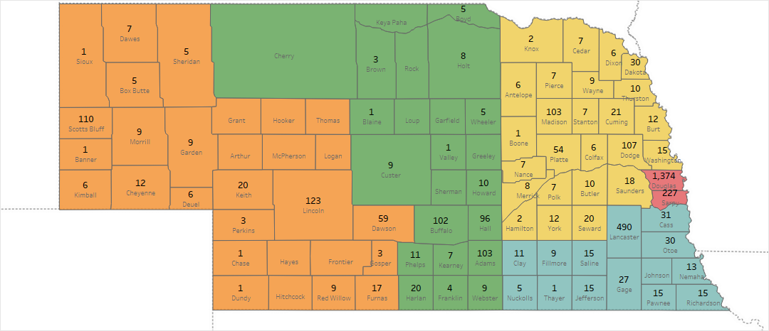

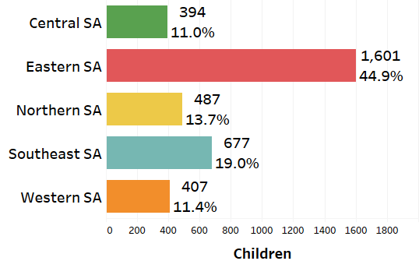

**Figure 2: Age Group of NDHHS Wards in Care on 6/30/2018, n=3,566**

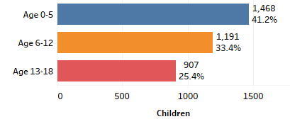

**Figure 3: Average Daily Population of NDHHS Wards**



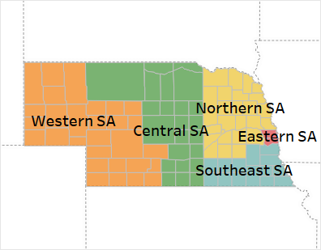

**Figure 4: Percent Change in Average Daily Population of NDHHS Wards by Service Area, June 2017 to June 2018**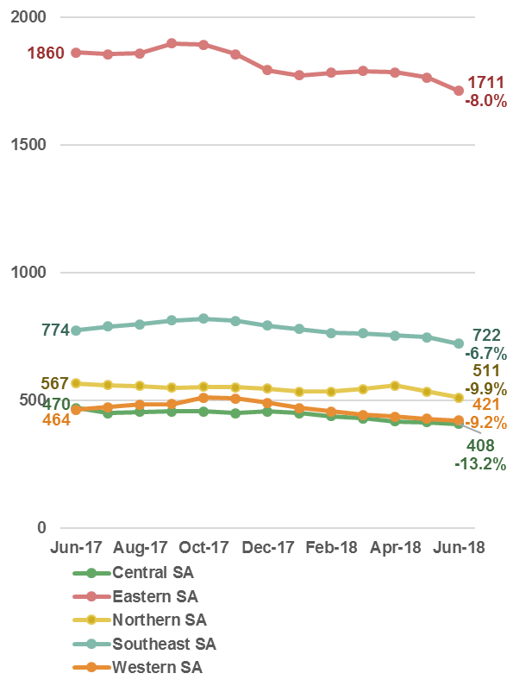

**Figure 5: Monthly Entries and Exits of NDHHS Population,**

**FY2017-18**

